Indigenous people have lived in the Amazon for thousands of years. For most of that time, they hunted, fished, and grew a variety of crops in small gardens. Their lifestyle was called subsistence, because they hunted and grew only what they needed to subsist, or survive. They practised a kind of agriculture called slash and burn.
Slash and burn sounds terribly hard on the environment, but if done properly it is one of the most environmentally friendly methods of farming. Farmers clear the land by slashing the trees and bushes, then burning them to release nutrients into the soil. They then grow crops in the new field.

The cleared area has no protective vegetation cover so nutrients are washed away (leached). Also there is no vegetation to form the layer of humus, which provides nutrients in the first place. As a result the soil becomes infertile. After four-five years the Indians move on and clear another part of the forest.

Later, they will return and clear an old field, now covered with the young trees of a secondary forest. This process is known as shifting cultivation.

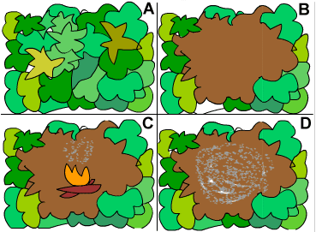
In the Amazon rainforest, an indigenous tribe called the Quichua often rotate their crops every year. That way their crops always have rich soil. Also, after a year in cultivation, a field becomes overgrown with natural vegetation. This helps replace nutrients.
A – An area of rainforest B – Indian’s clear the rainforest
C – The vegetation is set alight D – The ash is used as a fertiliser

- Define the following terms: indigenous people, subsistence farming and slash and burn

- Put the following boxes in order to show what shifting cultivation is. Include sketches if you wish.
An area of forest is cleared and the vegetation is burnt.
Indians spread the ash over the cleared soil.
Crops are planted and grow well in the nutrient rich soil and the hot and wet climate.
After 4/5 years the nutrients in the soil become exhausted.
Farmers move on to a new area of forest. The plot slowly recovers its vegetation as the nutrient cycle is restored.

- Why do farmers burn the vegetation once it has been cleared?

- In detail, explain why farmers have to move on after farming an area of land in the rainforest for four/five years.

- Sustainable means using something in a way, which means that it will still be available for future generations. How is shifting cultivation a sustainable method of farming in the rainforest?

- How does shifting cultivation ensure sustainability for the rainforest?

