Where do volcanoes and earthquakes occur?

In geography it is important to be able to describe geographical patterns. The map below shows some of the strongest earthquakes and active volcanoes in the world. Can you notice a pattern in the distribution (spread) of volcanoes and earthquakes?
North America
Asia
Europe
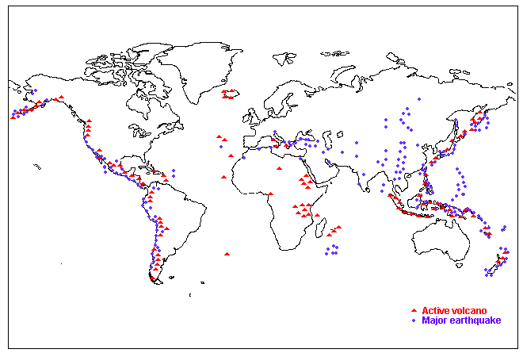
ffd
Map 1. The world patterns of volcanoes and earthquakes
South America
Australasia
Africa
- Look at map 1. It shows the distribution of the world’s active volcanoes and largest earthquakes. Write down the sentences from the list below which are true:

- Volcanoes and earthquakes happen all over the world.
- Volcanoes are found in narrow belts.
- Volcanoes are found along the East Coast of North and South America.
- Volcanoes are found along the West Coast of North and South America.

- Copy the paragraph below. Select the correct answers from the brackets.

- There are not many volcanoes in (Australasia/Africa) or (Europe/North America).
- Many of the volcanoes stretch along lines like the one down the side of (Europe/North America) and the middle of the Atlantic (Ocean/Continent).
- Many of the volcanoes are found in a big circle around the edge of the (Pacific/Atlantic) Ocean in countries such as the (UK/Japan). This is called the (Pacific Ring of Fire/Atlantic Ring of Fire)
3. In your own words describe the location of the world’s largest earthquakes.
Why do volcanoes and earthquakes occur where they do?
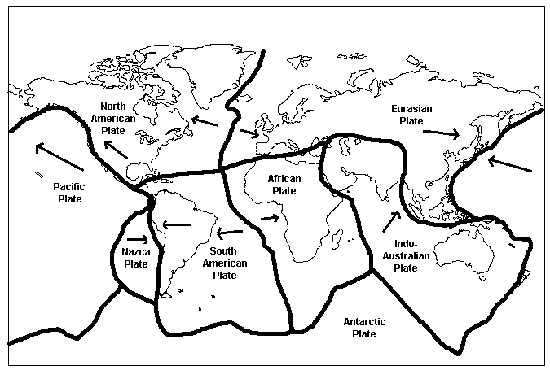
- Label the major plates onto your map of the world. Include arrows to show the direction each plate is moving.

- Label the plates using the key below you map.

- Identify the type of plate margin where the following plates meet (you may have to check your notes to complete this task)

 | Collision | Conservative | Destrucitve | Constructive
North American and the Pacific Plate
Indo-Australian and the Eurasian Plate
Eurasian Plate and the North American Plate
Pacific Plate and the Eurasian Plate

- Place your map beside map 1. What do you notice?
- Explain the location of volcanoes and earthquakes (this means give reason why they happen where they do).
- Using a coloured pencil crayon label the Pacific Ring of Fire on your map.
- What is the Pacific Ring of Fire?
- How is the Pacific Ring of Fire formed?

Title________________________________________

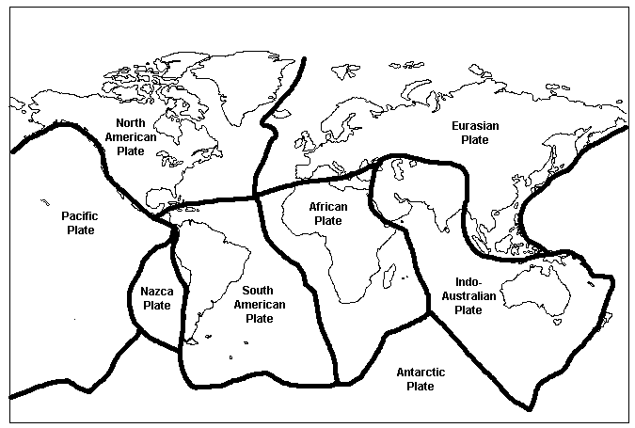Key

A. North American Plate | E. South American Plate
B. Nazca Plate | F. Pacific Plate
C. African Plate | G. Indo-Australian
D. Antartic | H. Eurasian

