Earthquakes – The Facts

These are the facts you need to know about earthquakes!
Read the information and complete the questions below.
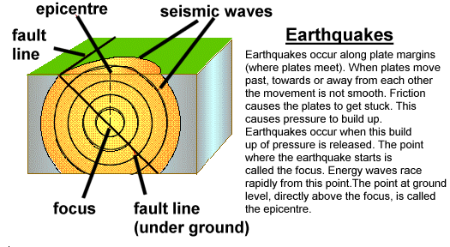
The strength or magnitude of an earthquake is measured on the Richter Scale. The Richter Scale measures earthquakes on a logarithmic scale. This means that an earthquake of magnitude 7 is ten times more powerful than one of magnitude 6 and 100 times more powerful than one of magnitude 5. The Richter Scale goes from 0 to 10.

- What are earthquakes?

- Define the following terms:

- Magnitude
- Epicentre
- Focus

- What is the Richter Scale?

- In as much detail as possible explain the causes of earthquakes (if you can try to go into detail about the different plate margins).

- Find 10 places where earthquakes have happened and write down the magnitude of each one.

