Year 7 Geography Homework Project Unit 1

GeoNet internetgeography

Get help online using GeoNet. There are lots of pages to help you with this project. You can even use it to ask your geography teachers for help! Follow the steps below to find help.

Step 1 Go to:

http://www.internetgeography.co.uk

Step 2 – Enter the web site

Step 3 – Click INS on the menu page.

Step 4 – Click your year
Name _______________________

Geography Teacher ____________________
The deadline for this project is _________________.

To complete this project you can use the Geography
department web site (see the information box), you
should use the library and CD-ROM’s. You can also
use the resources in your geography classroom.
If you need any help – ASK!

Section 1. The World

- Find out what a continent is (use a dictionary).

- Find out what a country is (use a dictionary)

- Find the names of the seven continents.

- Try to find the name of a country for every letter in the alphabet
e.g. A – Angola.

Section 2. The World in my life

- List all the places that have touched your own life during a week. This can include finding out where your clothes were made, where letters/telephone calls are received from, where your food is grown, where people you’ve met live, places mentioned in newspapers and on the television and ANYTHING ELSE YOU CAN THINK OF!

- Using an atlas label all the places on the outline map of the world on the next page.

A map to show the places that have touched my life during a week

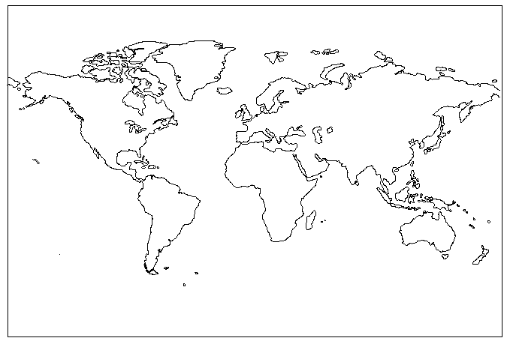

Section 3. Holiday Choices

In this section of the project you are going to investigate people’s holiday choices. You are going to find out where people have been, why they decided to go there, where they would like to go and the reasons for this.

- You need to design a list of questions to help investigate people’s holiday choices.
- Ask at least 10 people your questions. The more people you ask the better your investigation will be.
- You now need to present your findings. You could use graphs etc to show your results. This could include a bar graph to show the holiday choices of the people you interviewed.
- Describe what your results show.
- Try to explain why your results are like this.

You can get more help with this @ www.internetgeography.co.uk

