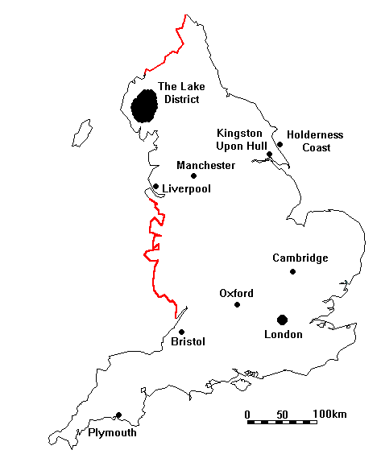
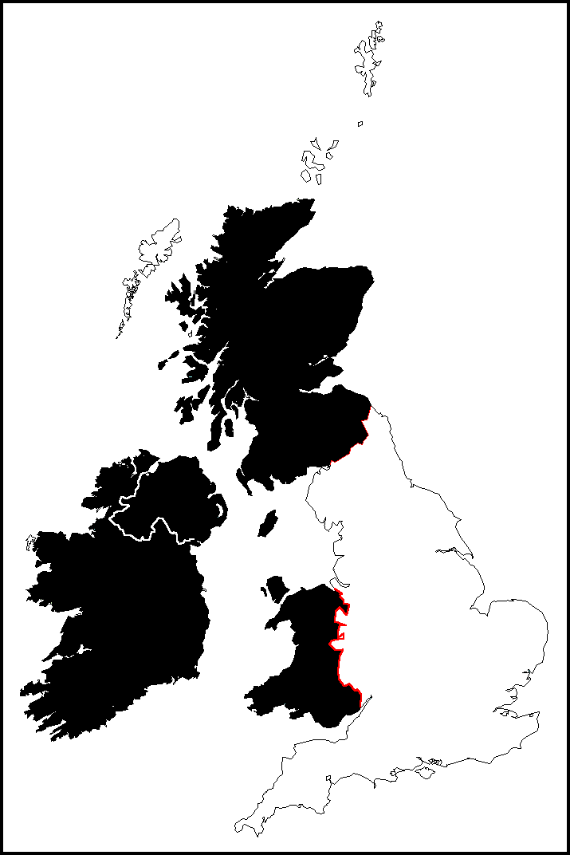
Day 2 - Tuesday

Travel from ________ to ____________.
This is a distance of ________kms.
There is a lot to see in _____________.
Main human features:

Main natural features:

Day 1 - Monday

Travel from ________ to ____________.
This is a distance of ________kms.
There is a lot to see in _____________.
Main human features:

Main natural features:
Day 3 - Wednesday

Travel from ________ to ____________.
This is a distance of ________kms.
There is a lot to see in _____________.
Main human features:

Main natural features:

Day 4 - Thursday

Travel from ________ to ____________.
This is a distance of ________kms.
There is a lot to see in _____________.
Main human features:

Main natural features:

Day 5 - Friday

Travel from ________ to ____________.
This is a distance of ________kms.
There is a lot to see in _____________.
Main human features:

Main natural features:

Then we return to Heathrow Airport at 10pm.

