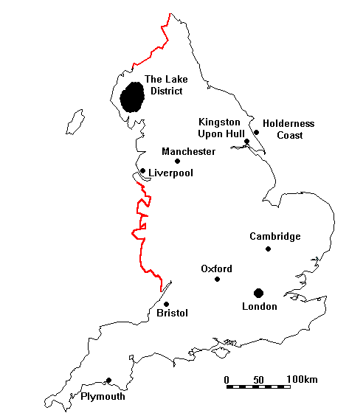
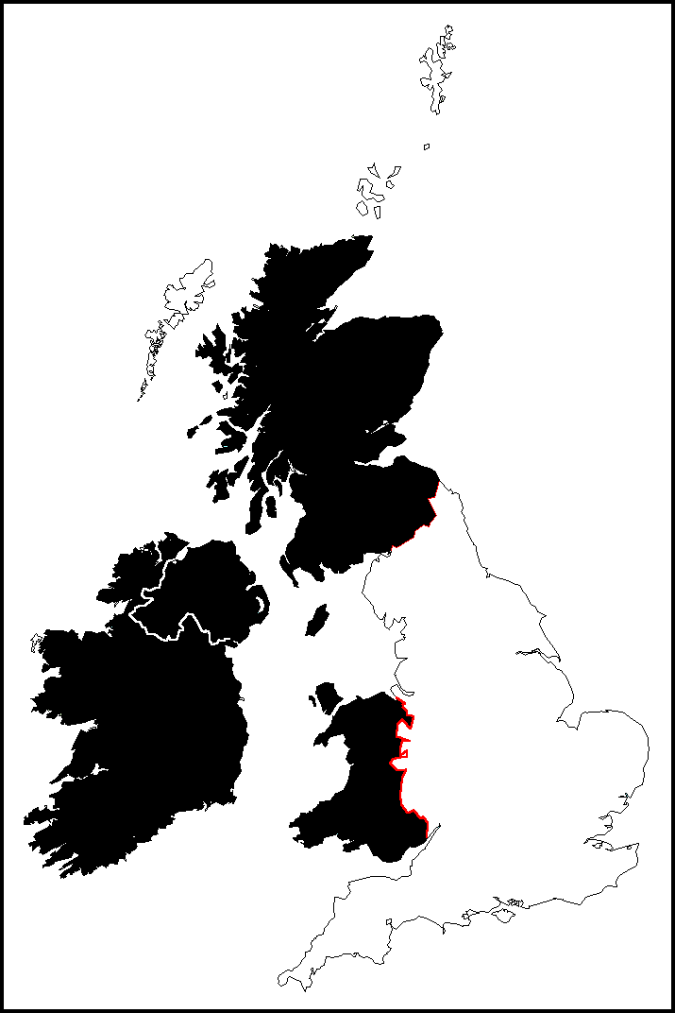
Day 2 - Tuesday

Day 1 - Monday

Day 3 - Wednesday

Day 4 - Thursday

Day 5 - Friday

