Revision - Test Yourself - Plate Tectonics - Foundation

Work your way through the questions below.

- Tectonic Activity

(A) What are the two types of tectonic plate?
(2 marks)
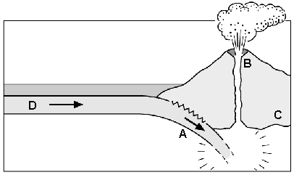
(B) The diagram below shows a plate margin.

(i) What type of plate margin is shown in the diagram?
(1 mark)
(ii) Match the following features to the letters on the diagram.
- Oceanic plate
- Continental plate
- Volcano
- Zone of subduction
(2 marks)
(C) What is an earthquake?
(1 mark)
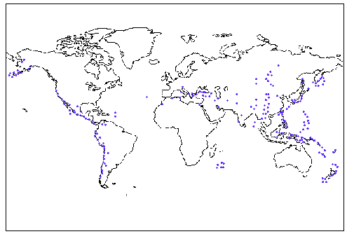
(D) The map below shows the distribution of earthquakes around the world.

(i) Describe the distribution of earthquakes around the world.
(3 marks)
(ii) Why do earthquakes sometimes happen in the same location as volcanoes?
(2 marks)
(E) Read the newspaper extract below about the Turkish Earthquake.

“The 1999 Turkish earthquake, measuring 6.9 on the Richter Scale, occurred at 3am local time. 15, 135 people died in the earthquake. Many people were killed as poor quality buildings collapsed. A further 24,000 were injured.
The Turkish Government predicts 600 000 people have been made homeless by the earthquake. Although the government has announced the construction of 200 000 new homes, these will take up to 3 years to build“.

(i) Identify 2 immediate problems caused by the Turkish Earthquake.
(2 marks)
(ii) Suggest 2 long-term problems caused by the Turkish Earthquake.
(2 marks)
(iii) Give three reasons why some earthquakes cause more deaths that others.
(3 marks)

Total - 18 marks

